Visualization of Unemployment and Crime Rate across USA

##### Mingxuan Luo u1266548 u1266548@utah.edu

##### Yulan Wang u1264235 youlan9115@gmail.com

##### Qing Ye u6007114 [q.ye@utah.edu](mailto:q.ye@utah.edu)

## Basic Info.

Project repository:

<https://github.com/blackispower/Unemployment-in-USA>

## Overview and Motivation.

Unemployment is describing the state that a person above some specified age is not in paid [employment](https://en.wikipedia.org/wiki/Employment) or [self-employment](https://en.wikipedia.org/wiki/Self-employment) and are currently available for work during the [reference period](https://en.wikipedia.org/wiki/Reference_period). It is measured by the unemployment rate. Factors influencing unemployment rate may be caused by the [recession](https://en.wikipedia.org/wiki/Recession) of economy, new [technologies](https://en.wikipedia.org/wiki/Technology), policies of the government and so forth.

Crime rate is defined by the ratio of crimes in an area to the population of the area, which is a count of crimes complied to assess the effectiveness of a crime control policy, and the impact of the policy on the risk of crime victimization.

In our project, we decided to visualize the unemployment and crime rates across USA between 2007 to 2018. We would like to reveal the trend of unemployment of specific regions (country- level, state- level) over time. Meantime, we analyzed the relationship between unemployment rate and Crime rate, income, population and visualize their change trend over time. We also found there is a strong influence of Financial crisis (2007–2008) on the unemployment rate, income and so forth.

We are interested in this topic because this is very relevant to our daily life. For individuals, these information could help them find an ideal place to settle down. For government, knowing the relationship between unemployment rate and crime rate could help goverment to make more effective crime control policy.

## Related Work.

Local Area Unemployment Statistics Map

<https://data.bls.gov/lausmap/showMap.jsp;jsessionid=79A96FEAED81F05DC79399CE15D59304._t3_07v>

## Questions.

### Reveal the trend of unemployment, crime rate of specific regions over time.

### Explore and compare the country- level and state- level unemployment rate, crime rate.

### Find the regions with extremely high or low unemployment or crime rate.

### Visualize the trend of unemployment, crime rate, income and population for specific regions. Check the correlation between crime rate and unemployment rate.

## Data

### Data sources

#### Unemployment rate data:

Kaggle: <https://www.kaggle.com/jayrav13/unemployment-by-county-us>

Bureau of Labor Statistics <https://data.bls.gov/timeseries/LNS14000000>

#### Crime rate and population data:

Crime in the U.S. <https://ucr.fbi.gov/crime-in-the-u.s>

#### Income data :

<https://www.census.gov/topics/income-poverty/data/tables.All.html> (Following TA’s advice to get more date relevant to the unemployment rate. Poverty rate in state-level were not found, so we moved forward with household income data)

### Data Clean

The dataset provides us with the unemployment rate date in different counties across USA from 2007 to 2018.

#### Unemployment rate data:

First, we acquire the unemployment rate data for each county of each state from the website of United States Department of Labor (<https://data.bls.gov/lausmap/showMap.jsp;jsessionid=79A96FEAED81F05DC79399CE15D59304._t3_07v>). Since the raw data is county-level, we need to preprocess the data to get aggregation of the data from county to state. Finally, we have the county level- unemployment rate data shown as Figure 1, and state level unemployment data shown as Figure 2. Since we only could get unemployment rate in county level, after meeting with our TA Ilkin, we decided not to show the county-level data.

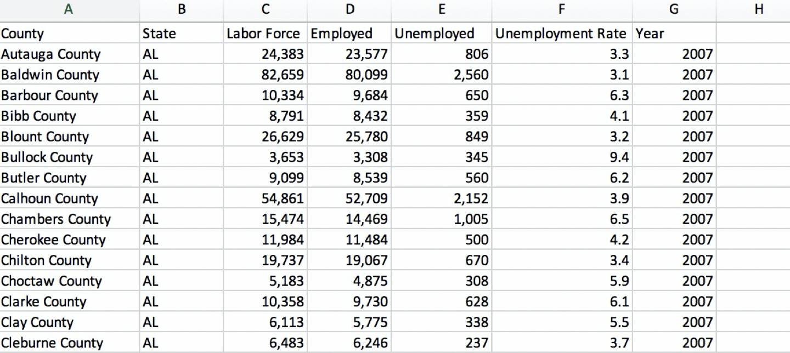

Figure 1. Unemployment data for each county of the US from 2007 to 2018.

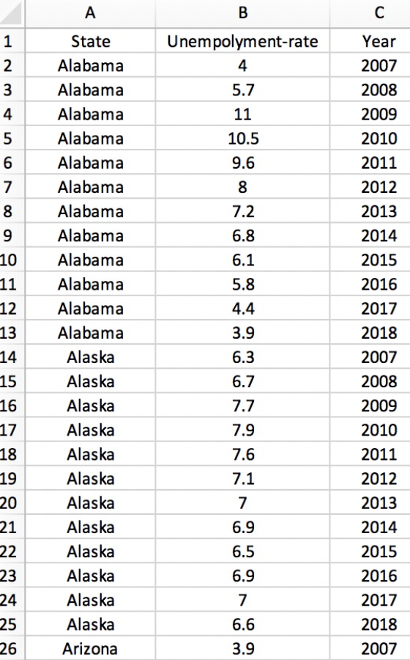

Figure 2. Unemployment data for each state of the US from 2007 to 2018.

#### Crime rate data:

For the crime rate data, we collected the data from the website <https://ucr.fbi.gov/crime-in-the-u.s>. After simple data clean process, the crime data is shown as Figure 3.

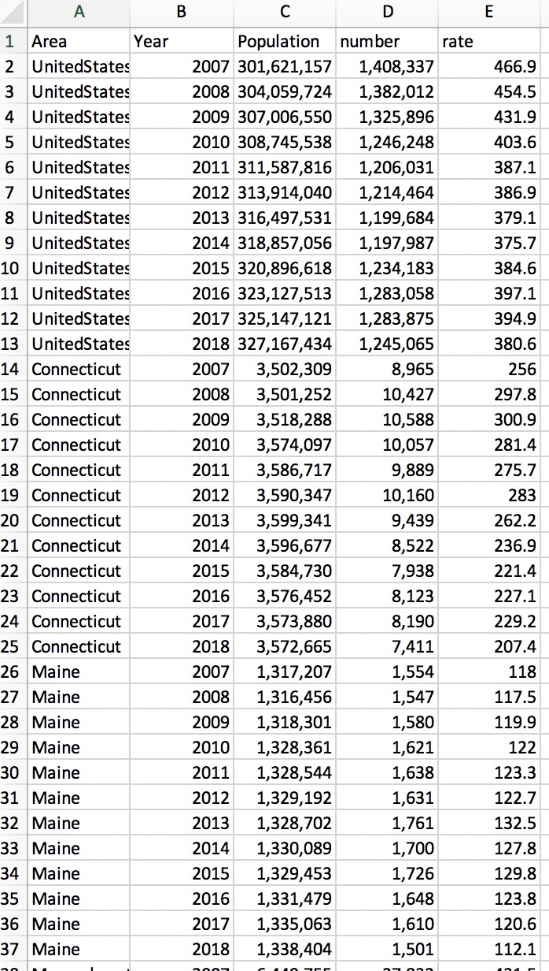

Figure 3. the crime data for each state in the US from 2007 to 2018.

#### Income data :

Original income data are difficult to read and use in this project (Figure 4), we used a python script to automate the cleaning and get each state’s information including unemployment rate, population, unemployment rate by year (Figure 5).

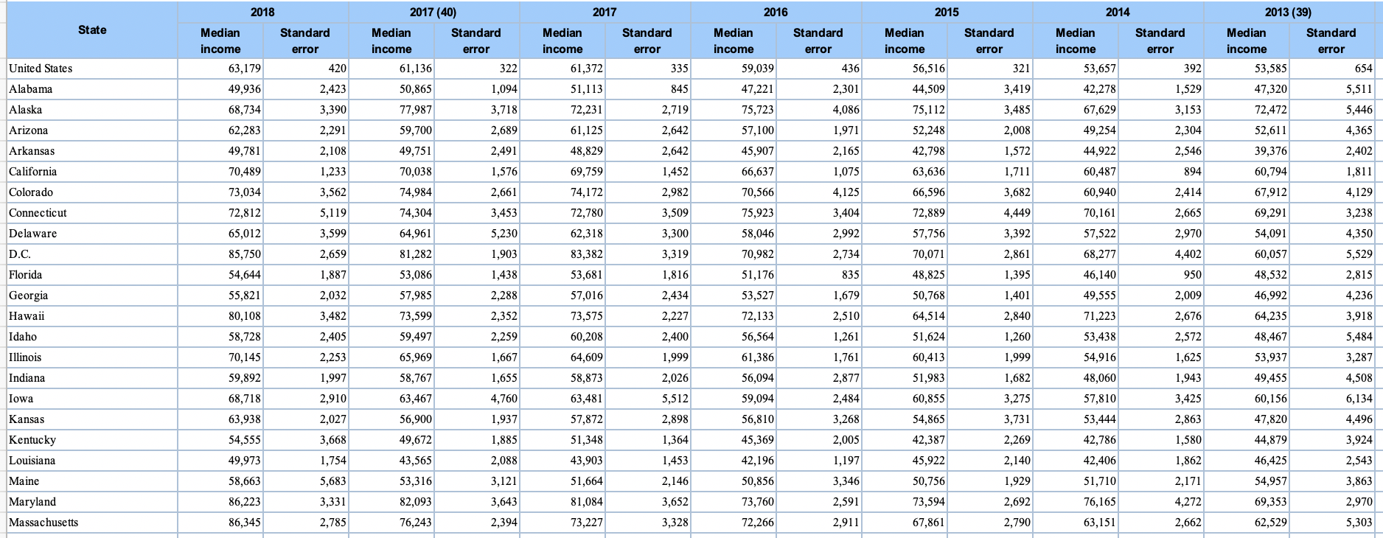

Figure 4. Original data of household income

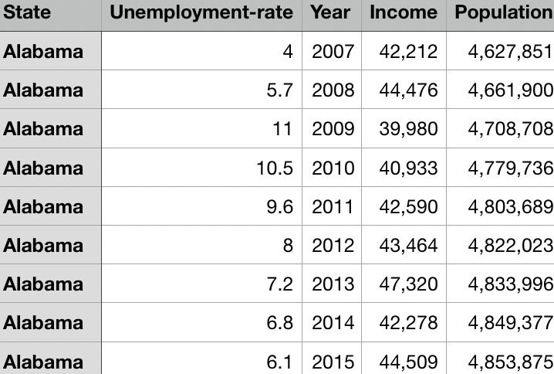

Figure 5. Python-cleaned data combining unemployment rate, income, population.

## Exploratory Data Analysis:

We have used 4 kinds of visulizations for our data, including map chart, line chart. bar chart and bubble chart.

First, we used map chart to shown the unemployment or crime data. The map makes it easy to understand the distribution of the organization’s presence across the city, state. And it is convenient to compare the activity across several locations at a glance, and contextualizing data in the real world.

Second, to visualize the data change trend, we used line chart. Line chart can show data variables and trends clearly and directly, which makes it easy to find some sharp increase and decrease, helping to let us think what might causes this abnormality.

Third, bar chart was used to visualize the data for each state or county. Compare to map chart, bar chart was marginated by length. The benefits of bar chart includes displaying relative differences of multiple categories, summarize the extremely value of the data.

Lastly, we are using bubble chart and related selection button to shown the correlation between the factors we are interested. Readers could use this function to explore what they are interested.

In addition, we also used several interaction in our project that including hover, zoom, sorting, linking among different graph.

## Design Evolution

### The original design:

#### Overview

The overview of the visualization consists of three parts: map chart, line chart and bar chart, and can toggle between the unemployment rate, the crime rate and the combined view.

Map chart is coded by color, suggesting the rate of unemployment/crime rate in each state. And on the combined view, the color indicates the unemployment rate while the crime rate is represented by the size of a circle. A year slider on the bottom can switch between different years. A tool tip should appear on hover. If a state is clicked, the map would zoom in and show a more detailed unemployment rate information in different counties. (Figure 6-8).

Line chart for the first two view shows the change over the years and it would highlight the corresponding line for a state when hovering on a specific one. It changes into a scatter plot with X-axis and Y-axis showing the stastitics. When clicking on a state, because we only have data for unemployment rate for each county, the line chart only show changes for the unemployment rate for each county. A description box shows the crime rate and overall unemployment rate in the state. (Figure 6).

Bar chart shows the comparison between states/counties for a specific year. Hovering on map or a bar would highlight each other. The whole chart could sort by alphabetic order or the statistics (Figure 6).

#### Must-Have Features.

Three views for the map chart and the corresponding functions in line and bar charts

#### Optional Features.

Zooming function for each counties’ data. However, after discussing and with the permission from TA, we decided to drop this freature cause we could only obtain the unemployment rate in county level.

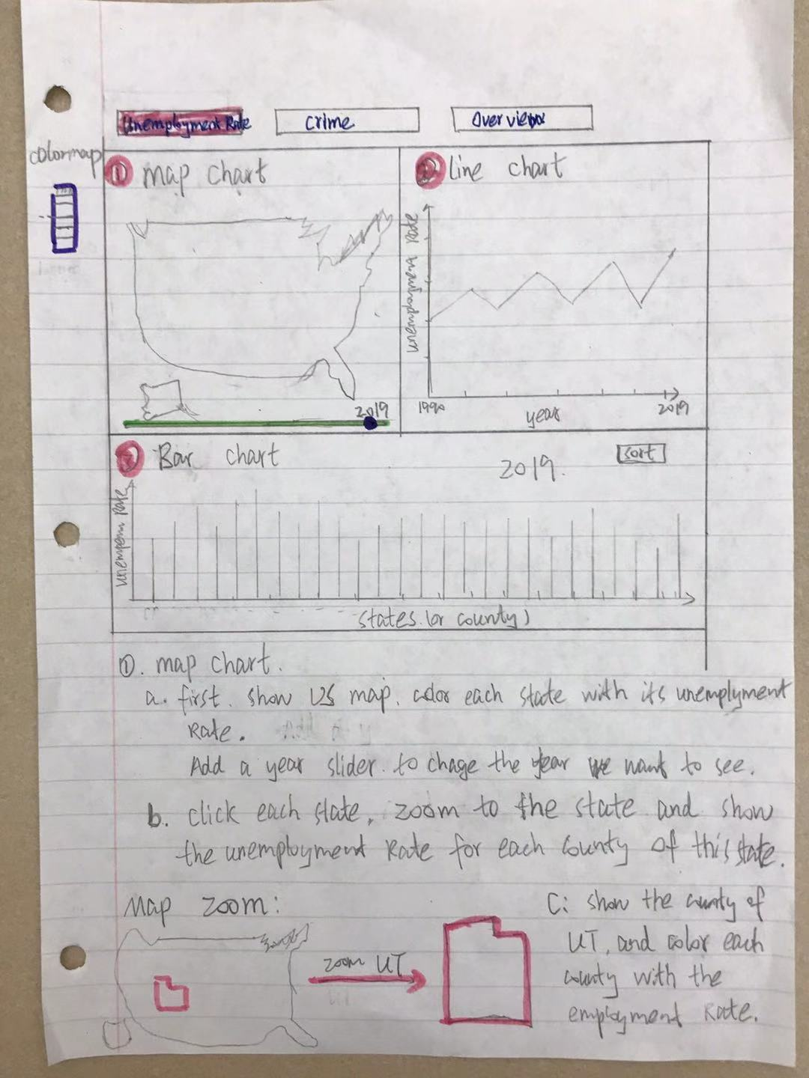

Figure 6. Original design- Part 1

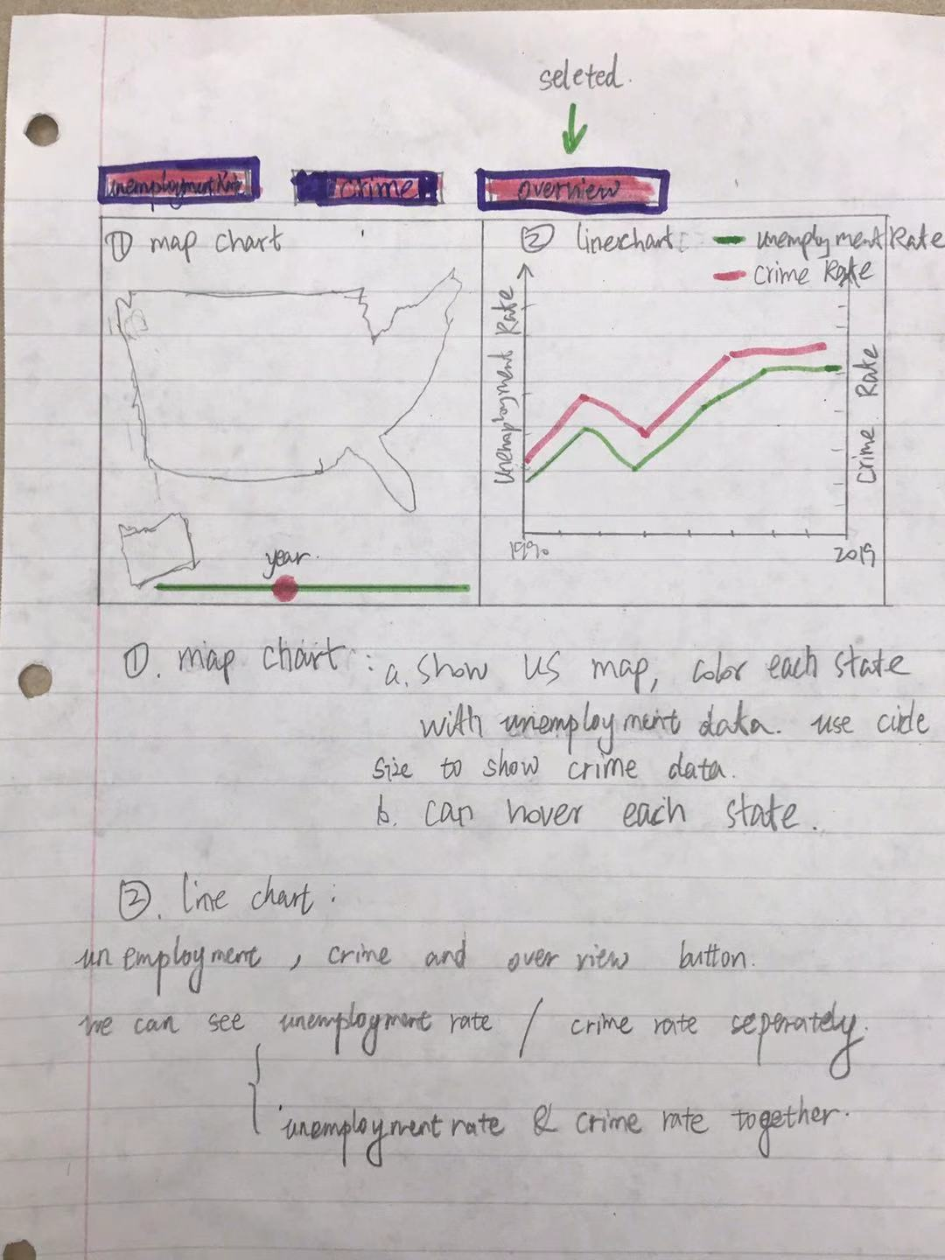

Figure 6. Original design- Part 2

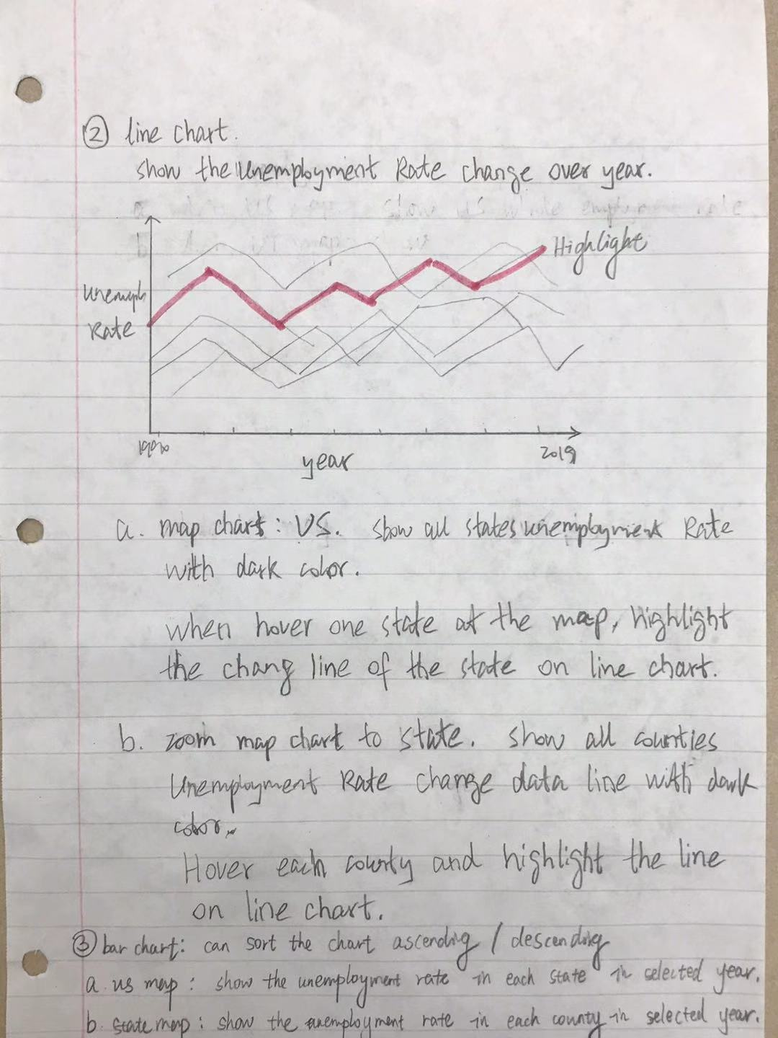

Figure 6. Original design- Part 3

### Implementation.

1. There are 3 main views in our design:
2. Unemployment rate among different states (2007-2018). Shown with map chart, line chart and bar chart.

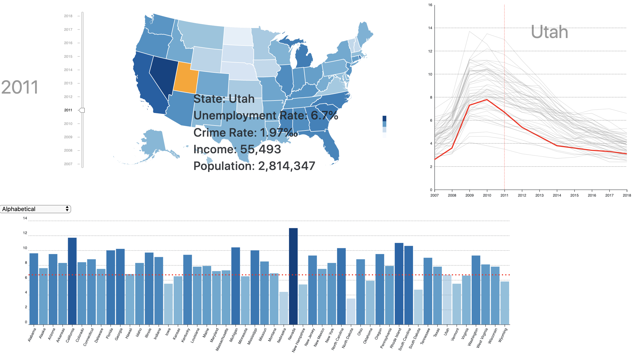

Figure 7. overview of unemployment rate page

1. Crime rate among different states (2007-2018) Shown with map chart, line chart and bar chart.

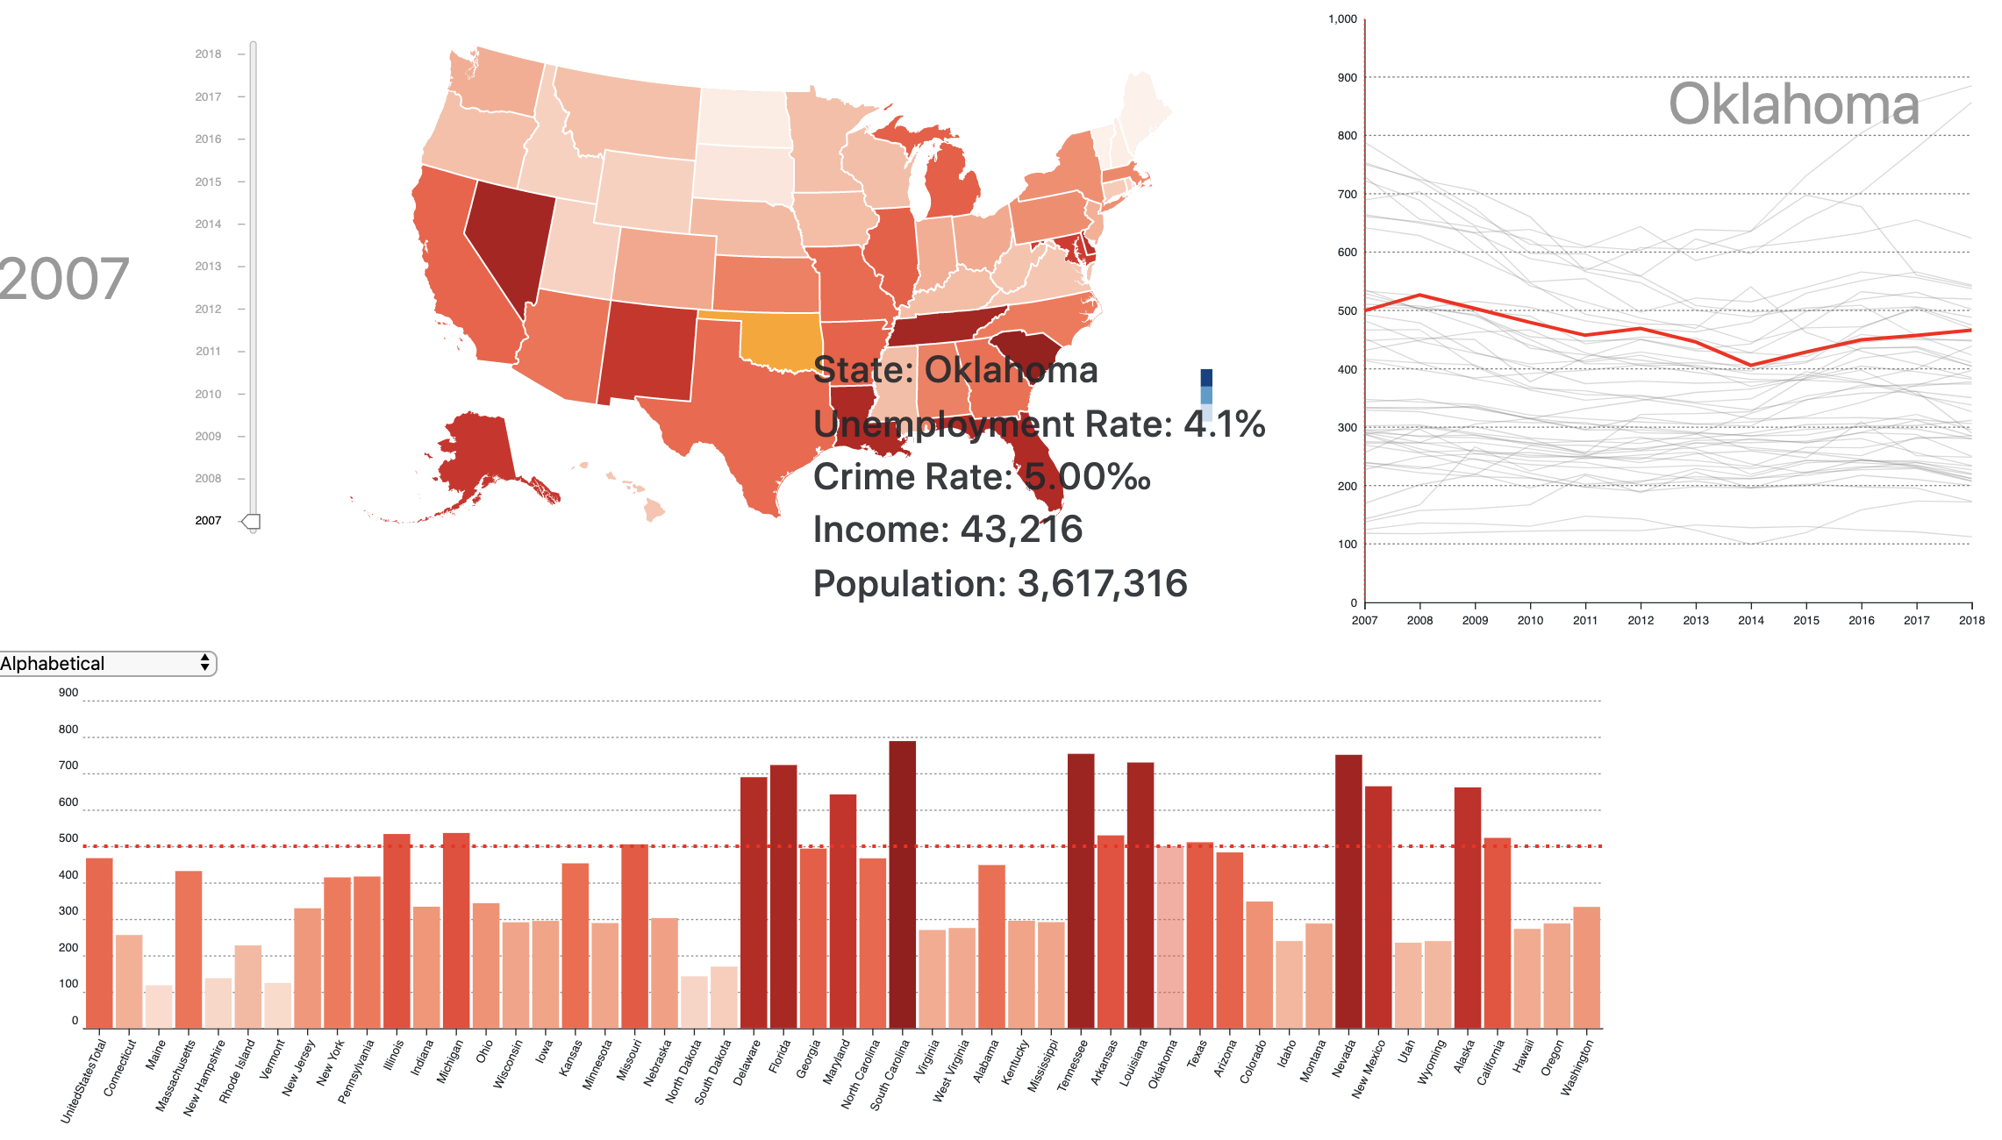

Figure 8. overview of crime rate page

1. Combined view to show the correlation between population, household income, crime rate and unemployment rate (among different states (2007-2018). Shown with line chart and bubble chart.

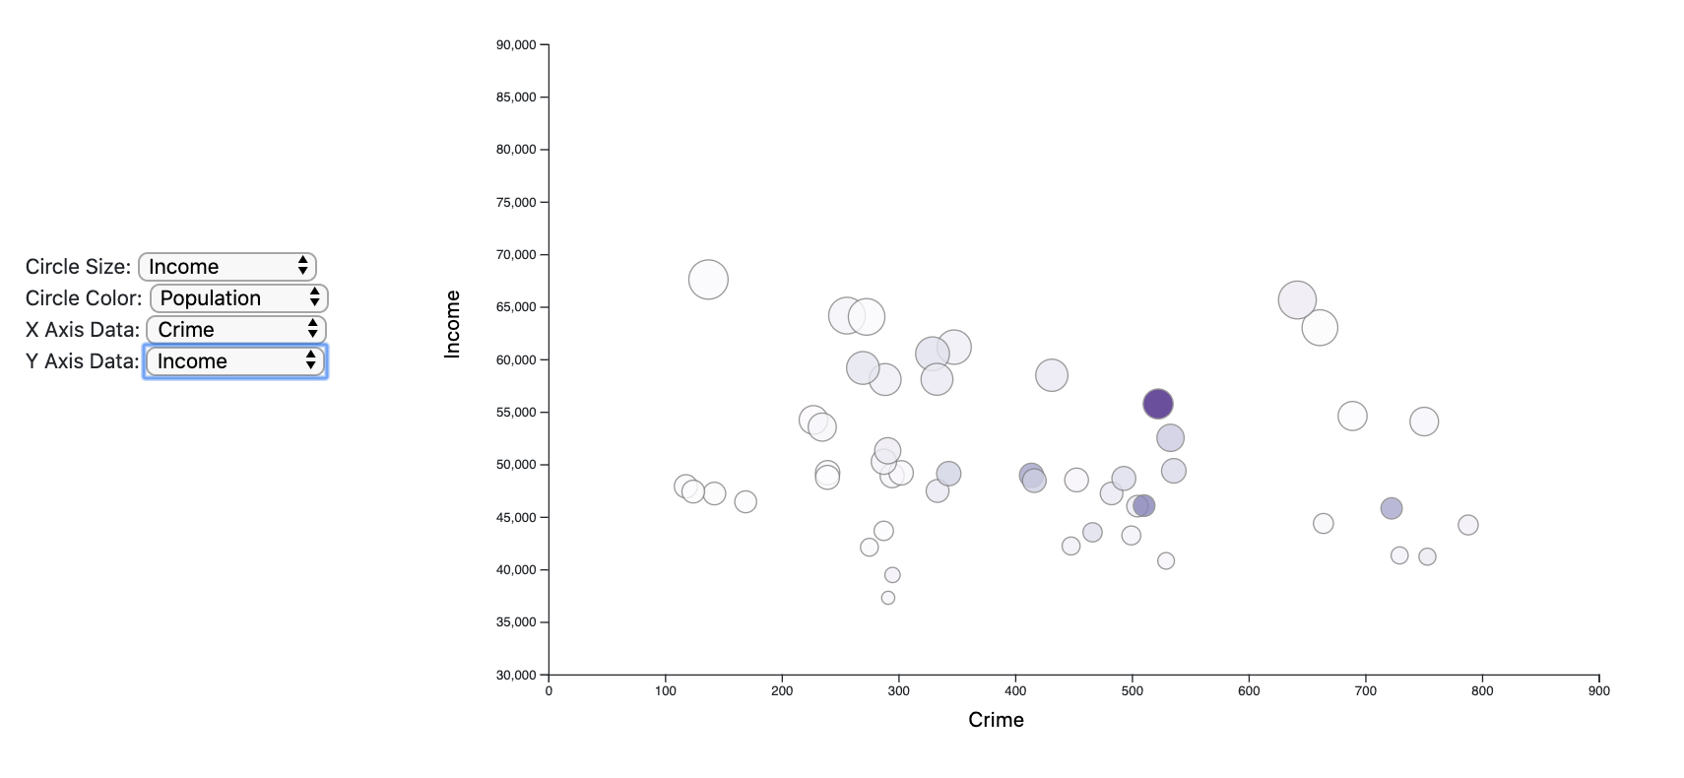

Figure 9. overview of combined page

#### The map chart

In the map chart, we colored each state based on the crime rate or unemployment rate based on the view the reader choose. When hovering on a state, the detailed information about the State name, crime rate, unemployment rate, population were shown. And the related states were also highlighted in the line chart and bar chart.

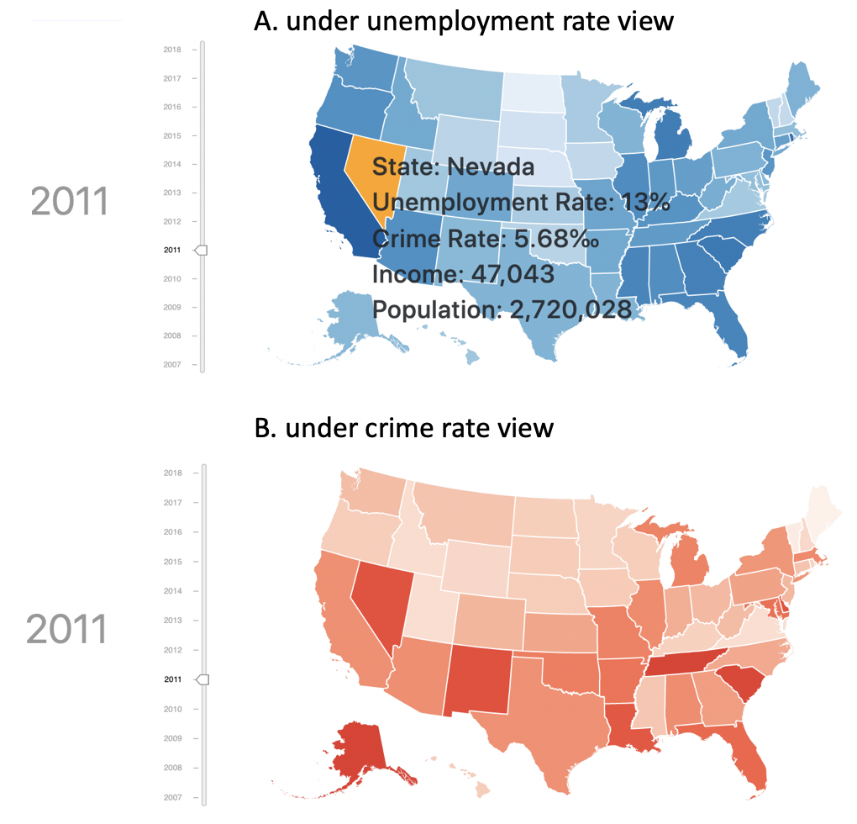

Figure 10. map chart of crime/ employment rate of the US.

#### The line chart

The change trend of unemployment or crime rate for specific area. The line corresponding to seleted state would be hightlighted.

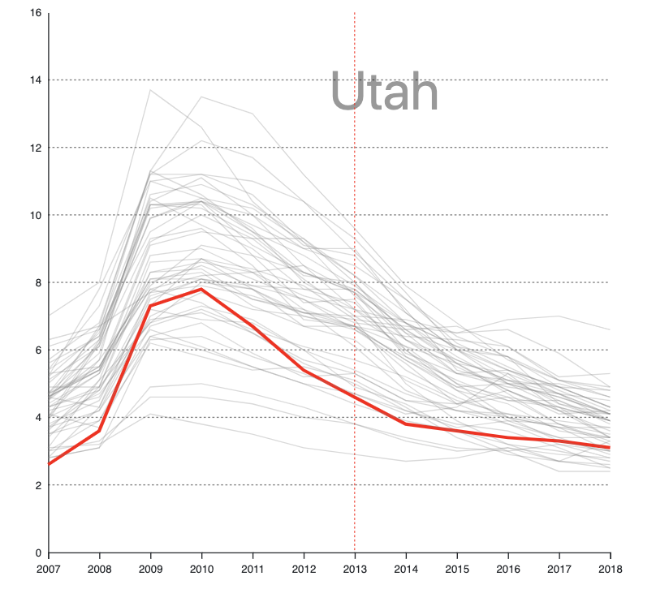

Figure 9. trend of crime rate at the US from 2007 to 2018.

#### The bar chart

For the bar chart, in unemployment rate view or crime view, when we select specific year with year slider, the bar chart shows the unemployment rate or crime rate for all states. The bars can be sorted by “Alphabetical”, “Frequency, ascending” or “Frequency, descending”. Each bar can be hovered. Animation were added during the sorting process.

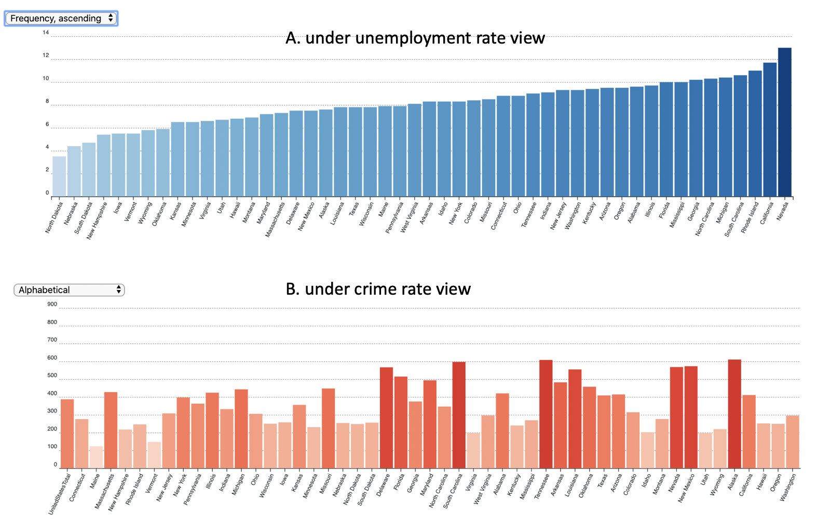

Figure 10. crime rate of each state in the US at 2010.

#### The Bubble Chart:

The bubble chart is shown in combined view. With selection button, the readers could use the date among the four factors to plot the bubble chart with x-axis data, y-axis data, circle size and color.

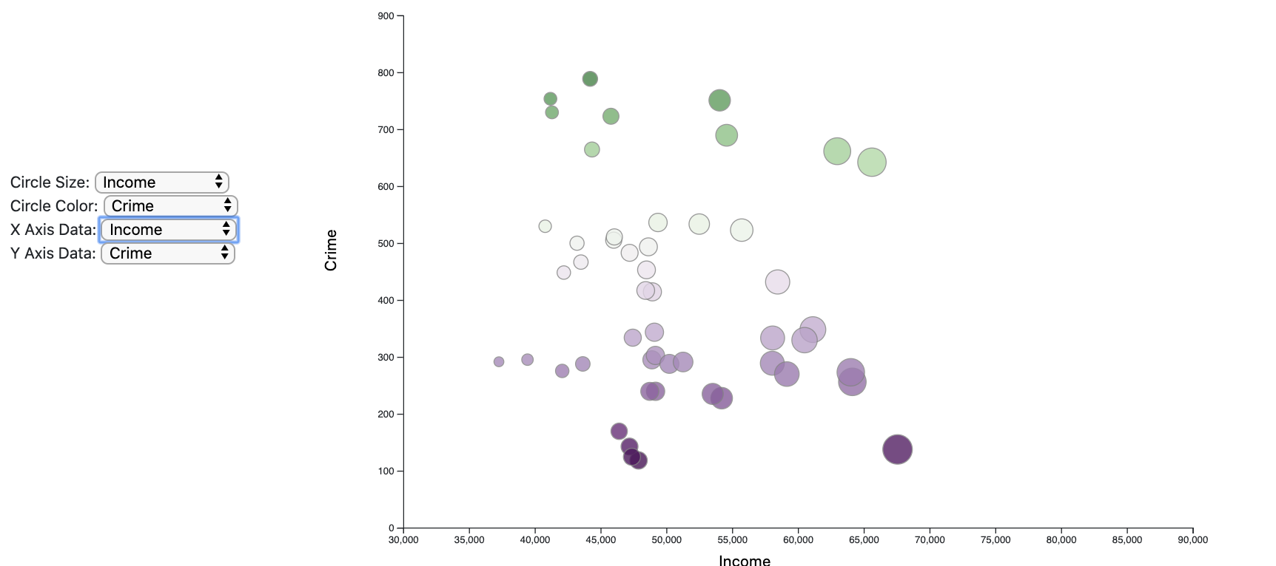

Figure 11. bubble chart shown the correlation between the four factors

#### Story Telling:

we find there is a sharp increase in unemployment rate among 2008- 2010, which might be caused by the famous 2007- 2008 financial crisis. The unemployment rate takes about 5 years to recover the level of 2007 (until 2014).

## Evaluation.

#### Learning:

1. Based on the map chart, we could know the unemployment or crime rate difference around the distributions of the US. For example, The crime rate/ unemployment rate of Nevada is very high.
2. Based on the bar chart, the unemployment or crime rate order of specific state could be identified. With sorting, the extremely value (the highest and the lowest) of data are easy to distinguished.
3. Based on the line chart, the change trend of data (unemployment or crime rate) is easy to understand. For example, we find there is a sharp increase in unemployment rate among 2008- 2010, which might be caused by the financial crisis (2007–2008).
4. Based on the bubble chart, correlations between those factors (crime rate, unemployment rate, population and household income) are easily to be seen. However, we could not draw a clear conclusion based on this chart.
5. Storytelling: we find there is a sharp increase in unemployment rate among 2008- 2010, which might be caused by the financial crisis (2007–2008).